**1.**

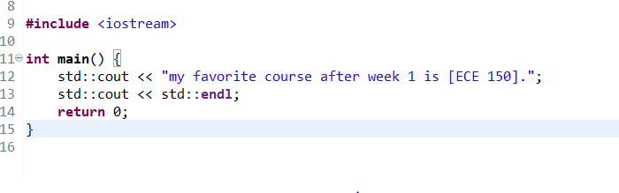

**2.**

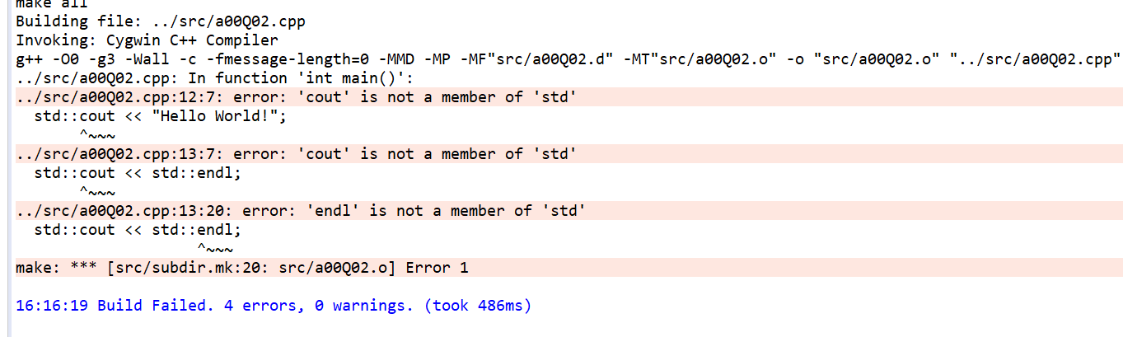

The complier cannot find ‘cout’ and ‘endl’ in ‘std’

**3.**

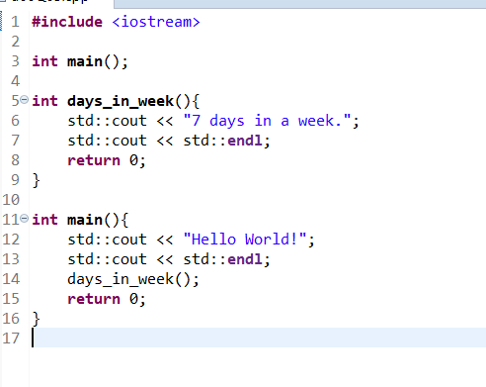

**4**. these statements will be operated in the order of 2 1 4 3 5.

**5.** Function declaration is to tell the complier there is a function has this name.

Function definition is the actual body of the function.

**6.**

123

1.23

‘a’

“Hello World!”

True

**7.**

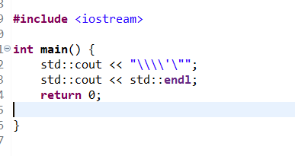

**8.**

std::endl can flush the output buffer and make the program more stable.

9.

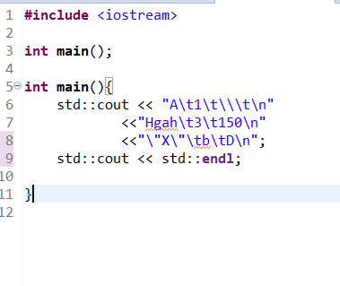

**10.**

No. Because keyword Identifiers are reserved with special meaning. a function prototype cannot be defined by keyword identifiers.

**11.**

N2354353g3

L43284969

**12.**

1. it will return an error of "division by zero"

2. it will print 10

3. it will print 10

**13. & 14.**

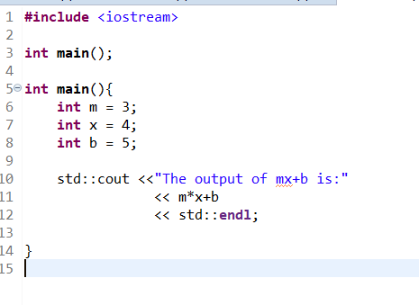

15.

“Std::cout << a*x*x*x + b*x*x + 3; “ works

**16.**

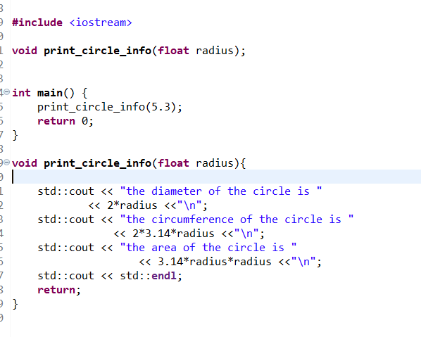

**17. & 18.**

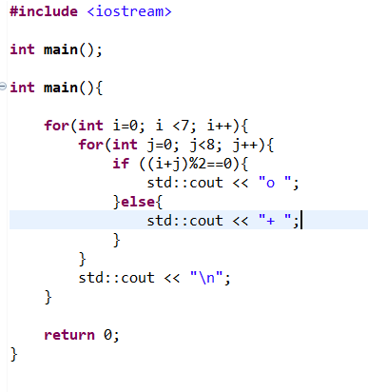

19. & 20

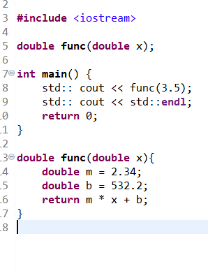

21.

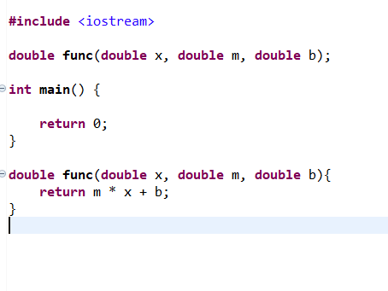

22. sorry I don’t want to input them.

23. to prevent printing the connected word “EliberthGilthoniel,”

24. it will print a new line (has the same function of “\n”) and flush the output buffer

25.

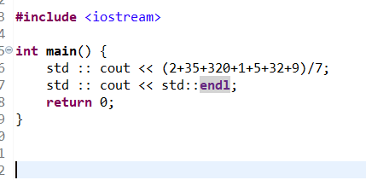

It will print 57.

26.

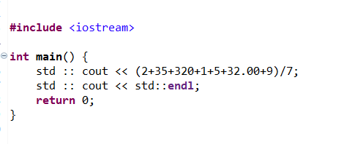

It will print 57.7143 because after adding 32.00, the type of data will be upcasted to double, so that the result will be double.